Keynote Speaking:

Design and Control for Linear Induction Machine and Drive System Based on Urban Transportation
Urban transportation, e.g. linear metro, driven by linear induction machine (LIM) has been paid much more attention both by academic and industrial communities recently for its direct thrust drive, strong climbing ability, flexible line choice, smaller cross section area, lower noise, etc. However, this system is greatly different with traditional rotary IM due to its cut-open primary (end effect), vertical force resulted from the asymmetric structure, and so on. There exists great difficulty for accurate modelling for LIM influenced by nonlinear circuit and partial magnetic saturation. This speaking will introduce one new reasonable equivalent circuit for LIM performance analysis, as well as some specific design and control case studies. Afterwards, advanced control strategies, like efficiency optimization control, model predictive control, will be employed to further increase the LIM drive indexes, such as average torque, efficiency, etc. Finally, some emerging techniques like system-level optimization on LIM will be discussed.

Biography of the presenter
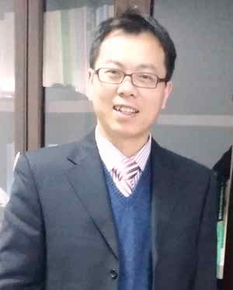
Wei Xu (M’09-SM’13) received the double B.E. and M.E. degrees from Tianjin University, Tianjin, China, in 2002 and 2005, and the Ph.D. from the Institute of Electrical Engineering, Chinese Academy of Sciences, in 2008, respectively, all in electrical engineering.
From 2008 to 2012, he made Postdoctoral Fellow with University of Technology Sydney, Vice Chancellor Research Fellow with Royal Melbourne Institute of Technology, Japan Science Promotion Society Invitation Fellow with Meiji University, respectively. Since 2013, he has been full professor with the State Key Laboratory of Advanced Electromagnetic Engineering and Technology, Huazhong University of Science and Technology, China.
Prof. Xu mainly focuses on the design and control of linear machines and drives, and mores details about his group, Center for Energy Conversion System (CECS), can be found by http://machinececs.seee.hust.edu.cn/.
Prof. Xu is Fellow of the Institute of Engineering and Technology (IET). He is the General Chair for 2021 International Symposium on Linear Drives for Industry Applications (LDIA 2021), Wuhan, China. Prof. Xu has served as Associate Editor for several IEEE Journals, such as IEEE Transactions on Industrial Electronics. He has two books published in Springer, about 100 papers accepted or published in IEEE Transactions Series, and about 50 Invention Patents granted in the field of electrical machines and drives.

